Greenwash – Design and Requirements Artifact (SENG 401 L02, Group 02)

Non-Functional Requirements:
- Scalability
• The system shall support at players joining lobbies without performance degradation.
- Consistency
• All clients shall display the same current phase within 1 second of a phase change.
- Fairness
• The system shall ensure policy selection follows the configured deck distribution without bias.
- Clarity
• The resolution screen shall present the category and impact summary in readable format on mobile and desktop.
- Security:
• The server shall reject any action not allowed in the player’s current phase.

Functional Requirements:
The system shall allow players to join a single predefined lobby by selecting a join button.
The system shall require a minimum of five players to be present before the game can start.
The system shall assign each player a secret role at game start, ensuring that the number of Reformers is greater than the number of Exploiters.
The system shall privately inform players assigned the Exploiter role of the usernames of the other Exploiters.
The system shall not reveal any role information about other players to Reformers.
The system shall establish a fixed turn order for all players at the start of the game.
The system shall allow the current player in the turn order to propose a policy during their turn.
The system shall maintain and manage a shuffled deck of policy cards consisting of sustainable and greenwashed policies.
The system shall provide a discussion phase after a policy is proposed and before voting begins.
The system shall allow each player to cast exactly one secret vote to approve or reject the proposed policy.
The system shall enact approved policies and update the game state accordingly.
The system shall advance the turn to the next player after each completed round.
The system shall evaluate win conditions after each round and end the game when a team’s victory condition is met.
The system shall display a final game summary showing enacted policies and the winning team.

Sample of 6 cards from the deck:

Gigatonne Carbon Capture Roadmap
Card Front:
“Scale up Carbon Capture and Storage (CCS), a technology that captures CO₂ emissions from power plants and industrial facilities before they enter the atmosphere, compresses the carbon, and stores it deep underground in geological formations. Twenty years ago, global leaders projected CCS could capture 5,000 million tonnes of CO₂ per year by now — and we aim to accelerate deployment to reach that scale.”
Hover Text:
Twenty years ago we said 5,000 million tonnes per year.
Today? The world can barely capture 10 million tonnes.
Global emissions are 36 BILLION tonnes per year.
Even if we’d hit the original target, it would’ve contributed approximately… zero.
We promised 100 large-scale projects.
There are 6, because these useless things are so expensive, it makes no economical sense to make them, even if they did work (which they don’t).
But it sounds impressive, doesn’t it?

Chevron Gorgon Flagship CCS Project
Card Front:
“Support flagship CCS facilities like the Gorgon gas project in Australia, which captures CO₂ from natural gas processing, compresses it, and injects it underground to permanently prevent emissions from entering the atmosphere.”
Hover Text:
Chevron received $60 million of your tax money to make Gorgon (biggest CCS plant in the world) work.
2016: captured… zero.
2017: captured zero.
2018: zero.
2019: finally… got clogged up by sand.
To date, Gorgon has captured 30% of its target — and that’s just processing emissions.
Include the emissions when the gas is burned?
It captured barely 2%.
But Chevron stored 100% of that $60 million taxpayer dollars you gave them!
Capture and $torage.

Carbon Capture Utilization (CCUS) Energy Expansion
Card Front:
“Expand Carbon Capture, Utilization and Storage (CCUS), which captures CO₂ and repurposes it for productive uses — such as injecting it into oil reservoirs to enhance energy recovery while storing carbon underground.”
Hover Text:
That “productive use”?
Pumping CO₂ underground to squeeze out more oil.
That oil, once burned, can release more carbon than was captured.
You might call that bullshit.
But we call that “Carbon Capture Use”.
That’s why we added the “U”.

Clean Hydrogen with CCS
Card Front:
“Invest in clean hydrogen energy produced from coal or natural gas, with carbon capture technology used to trap emissions during production and store them underground, enabling low-carbon fuel for the future.”
Hover Text:
Forget green hydrogen made from renewables and water.
This “clean hydrogen” is made from coal or gas —
and can emit more than if you just burnt the coal or gas in the first place.
But don’t worry — we’ll bury that problem too,
With CCS, which has never worked in its history.

National Carbon Credit Market Expansion for Net Zero
Card Front:
“Expand the national carbon credit market to accelerate Net Zero by 2050.
Similar to how individuals can pay to offset their emissions from a flight, this system allows companies and governments to purchase carbon credits to compensate for their emissions. That money is spent on reducing emissions elsewhere, which is useful for offsetting emissions that are hard to avoid, like in aviation and agriculture.
Landholders earn one credit for each tonne of carbon emissions they prevent or avoid — such as by planting trees or choosing not to clear vegetation. These credits can then be sold to emitters like gas companies, who use them to offset their own emissions and then become carbon neutral.”
Hover Text:
You know how when you book a flight and pay a little extra to offset your emissions?
Now imagine that money wasn’t actually spent on reducing emissions.
Because under this system, credits are issued for things like:
• Growing trees that were already there
• Not clearing land that was never going to be cleared
• Planting forests where forests can’t even grow
As a result, 70–80% of these credits are low integrity… meaning they offset approximately…nothing.
Gas companies buy them to keep pumping carbon into the atmosphere while claiming neutrality.
Governments buy them to say “Net Zero by 2050.”
Everyone looks good.
Emissions keep rising.

Social Media Ban for Under-16s
Card Front:
“Introduce a nationwide ban on social media access for users under 16 to protect young people from harmful online content, cyberbullying, and addictive platform design.
The policy requires platforms to verify age and prevent under-16s from creating or maintaining accounts, ensuring a safer digital environment for children.”
Hover Text:
We all agree social media can be harmful. It’s polarising society, undermining democracy, and flooding brains with AI slop.
We could regulate toxic algorithms, ban addictive features, restrict gambling ads, and impose a real Duty of Care on platforms. But regulating billionaires is hard work, so let’s NOT do that.
So we banned the kids.
The law was rushed through in just 9 days, ignoring hundreds of experts, human rights advocates, digital rights groups, Indigenous organisations, and mental health experts.
Meanwhile, 73% of young people use social media for mental health support — including kids who are bullied, in abusive homes, or LGBTQ youth who found community online.
It won’t stop bullying, predators, gambling ads, or algorithm-driven brain rot. It just shifts the burden onto families while platforms keep operating exactly as before.
It looks like action.
It avoids actual regulation.
Doing Something — just not the thing that would fix it.

Diagrams

Use-Case Diagram
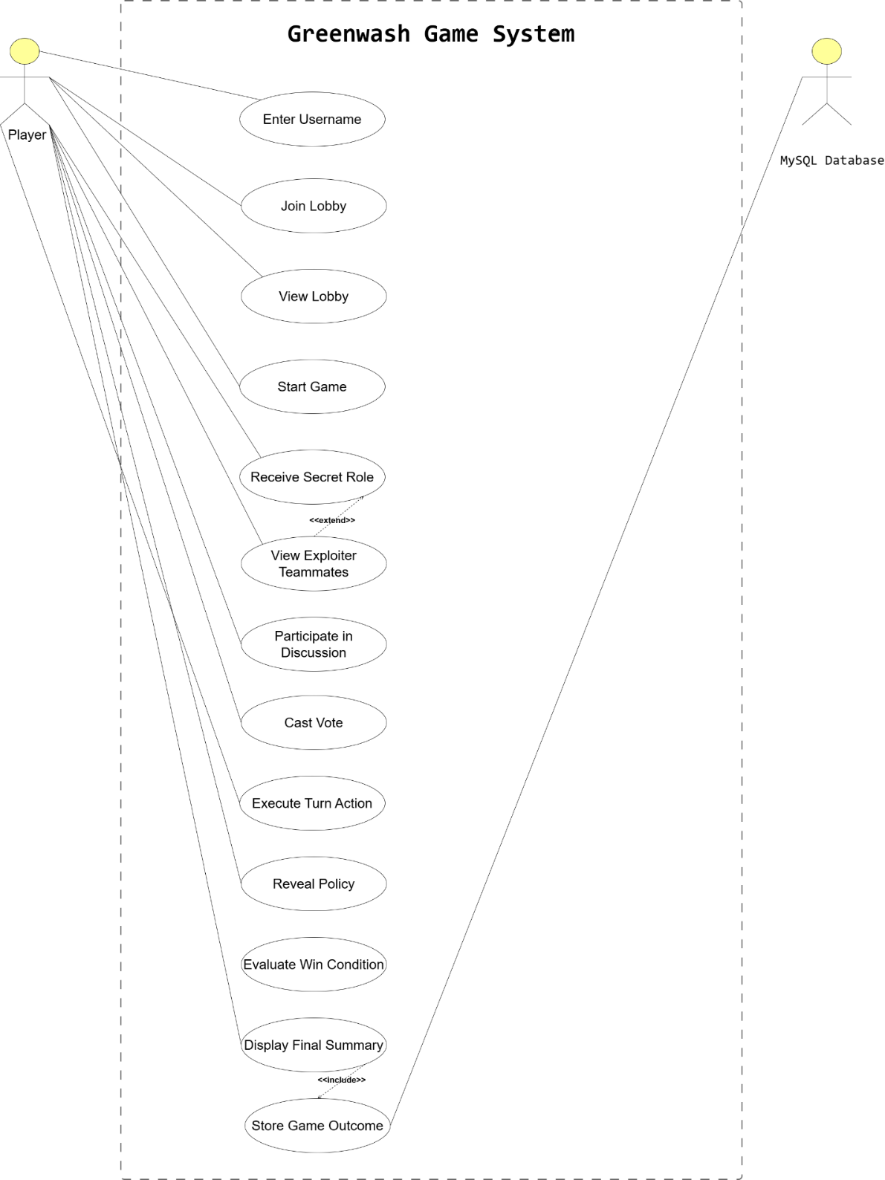

In - progress (skeleton class diagram):

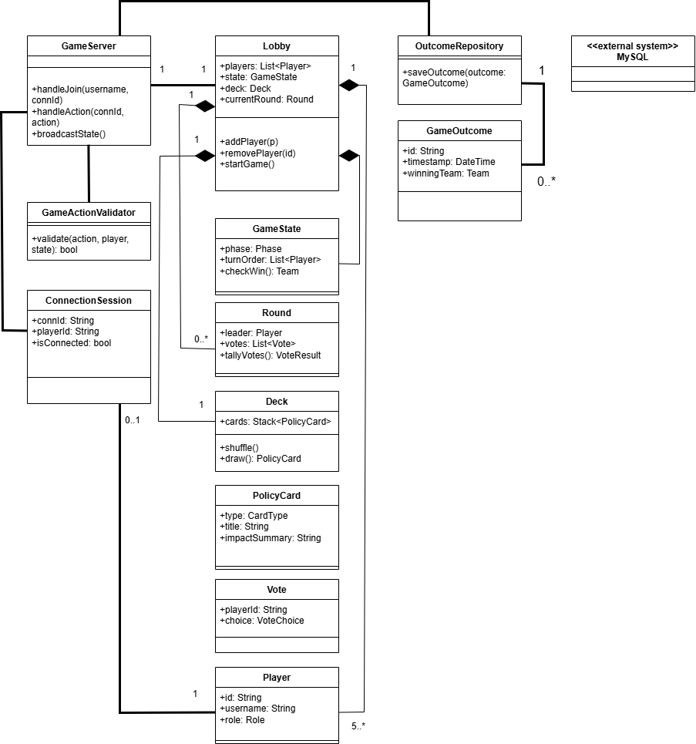

Updated diagram (completed):
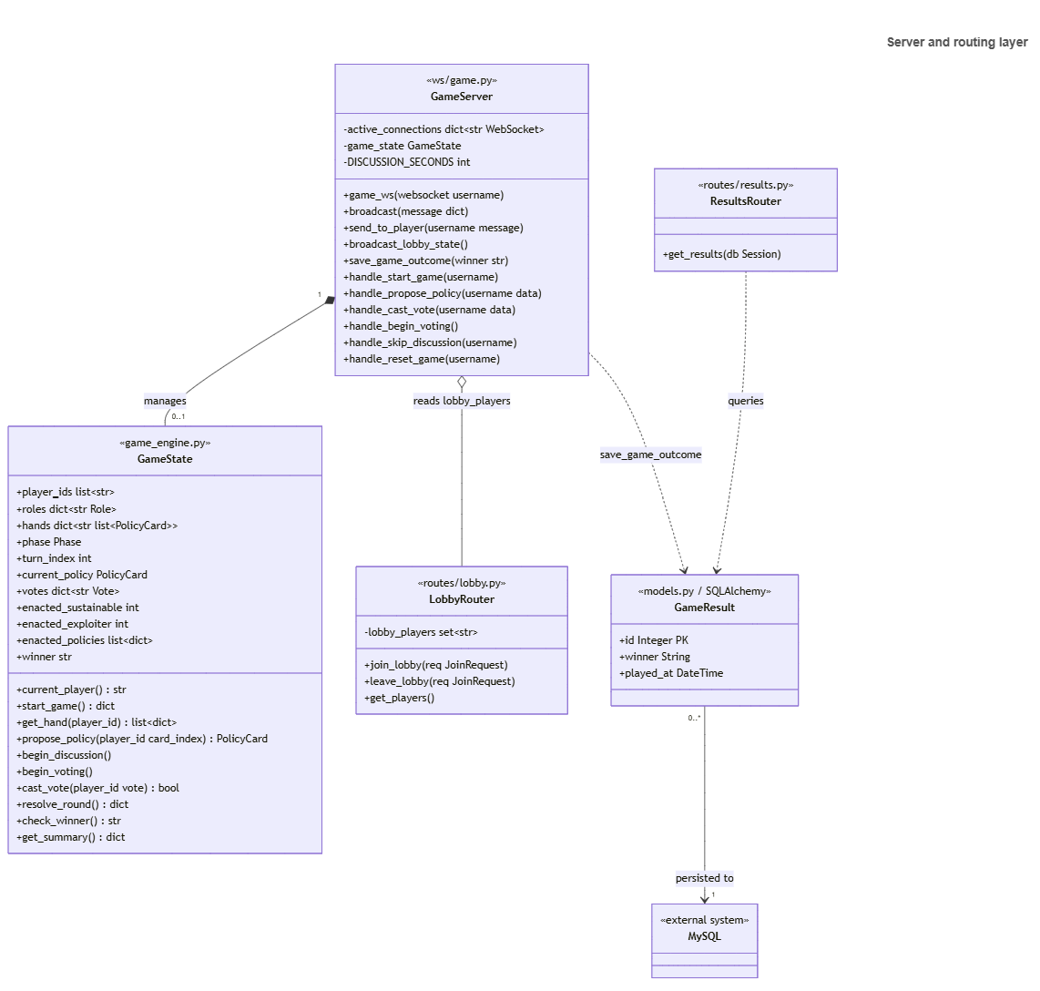
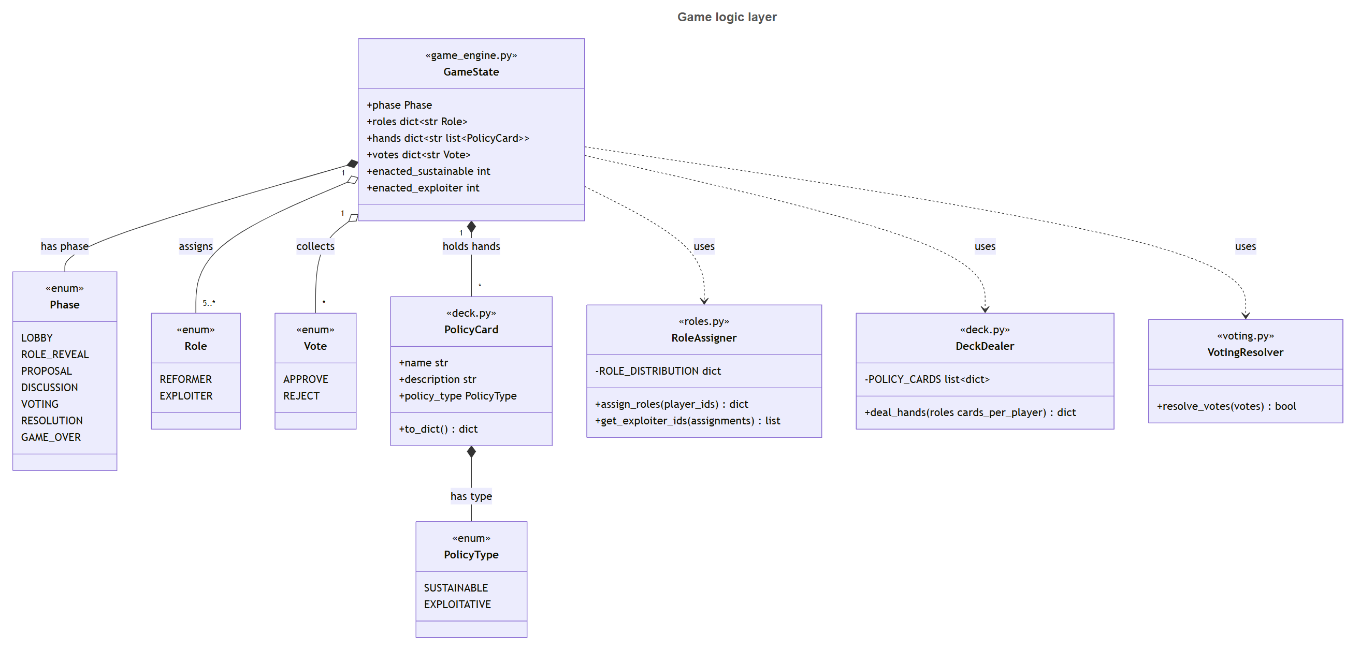
Activity Diagram:
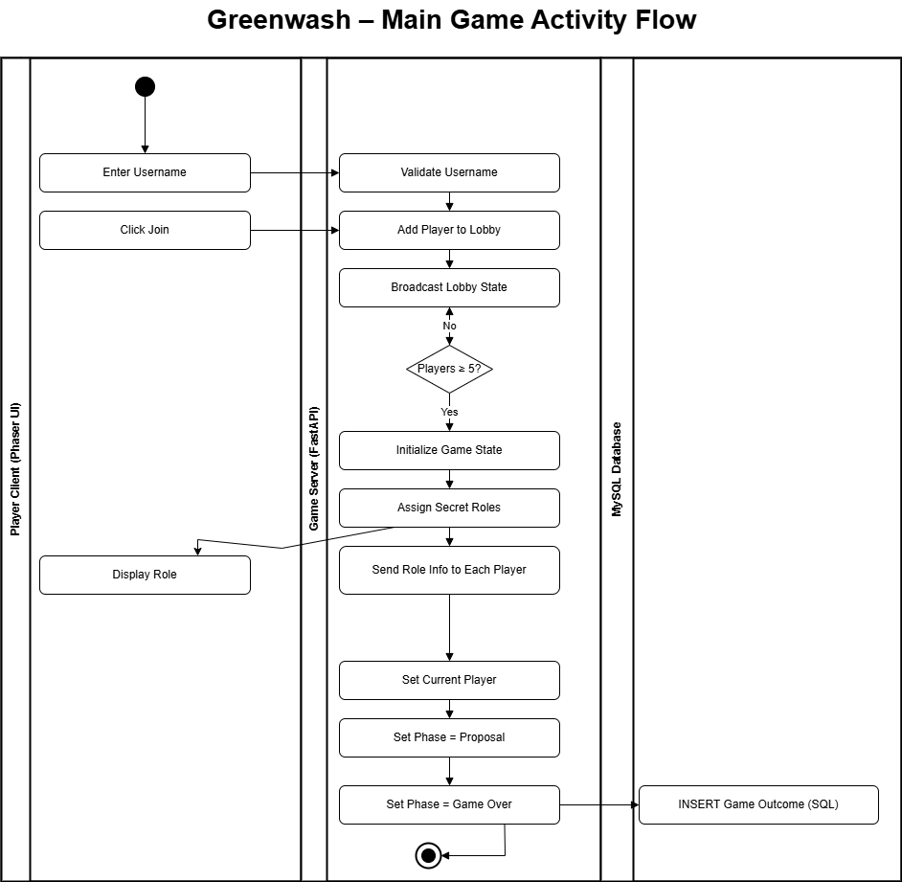

Polished version of Activity diagram:
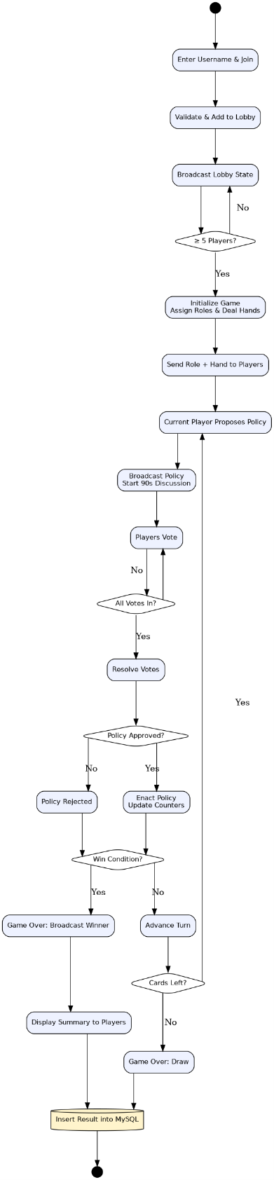

User Stories (End user needs)
As a player, I want to enter a username and join the lobby so that I can quickly participate without creating a full account
As a player, I want my username to be unique within the session so that my actions can be clearly identified during the game
As a player, I want to receive a secret role at the start of the game so that the social deduction aspect remains fair and engaging.
As a player, I want to vote on proposed policies each round so that I can influence the outcome of the game.
As a player, I want the system to accept only one vote per round so that the voting process remains fair
As a player, I want to see whether a policy was sustainable or exploitative after each round so that I understand the impact of the decision.
As a player, I want feedback on policy outcomes so that I can better understand sustainability principles and how decisions relate to the 17 Sustainable Development Goals.
As a player, I want the final game results to reflect the collective decisions made during the match so that I can evaluate whether our group made sustainable or exploitative choices
As a moderator, I want to view stored game outcomes so that I can verify the system is functioning correctly
As a moderator, I want the ability to reset the server state so that a new game can begin cleanly during demonstrations.
As a player, I want policies to be associated with sustainability themes so that I can recognize how decisions connect to real-world global goals.

